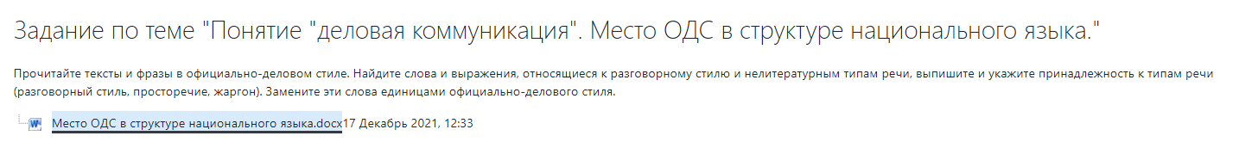

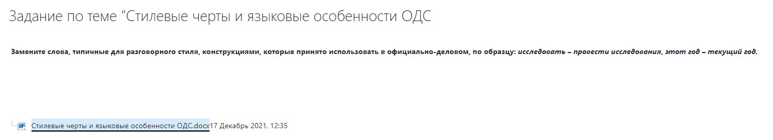

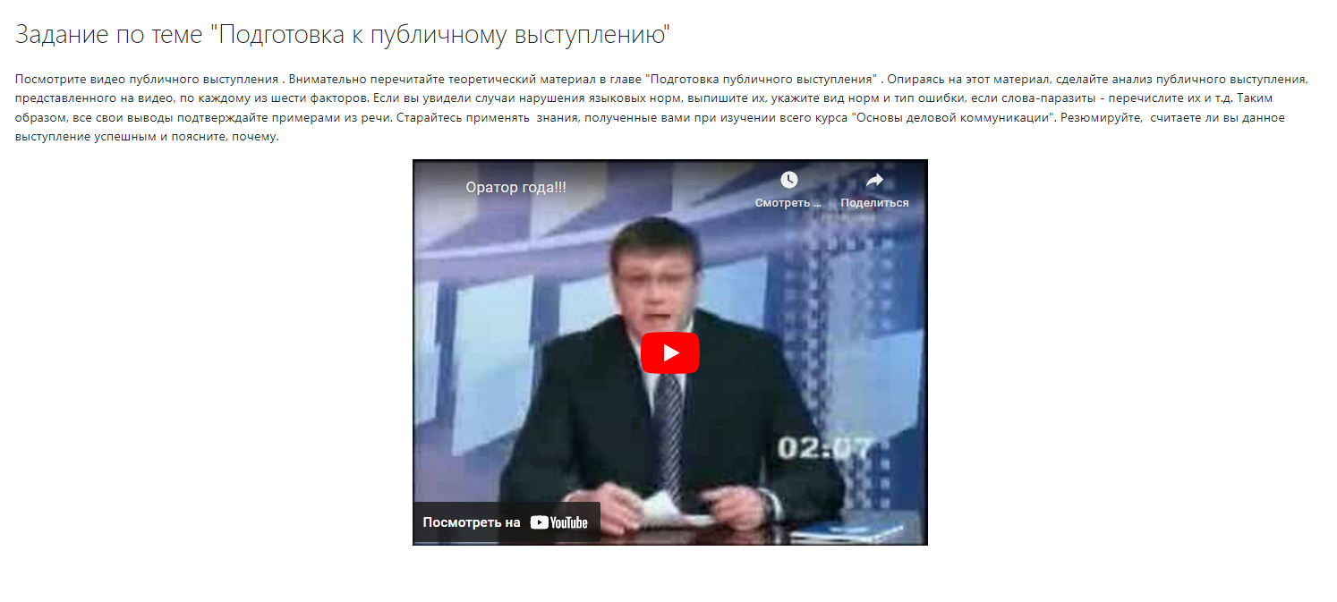
https://www.youtube.com/watch?v=-WloAA02MPA&t=1s

