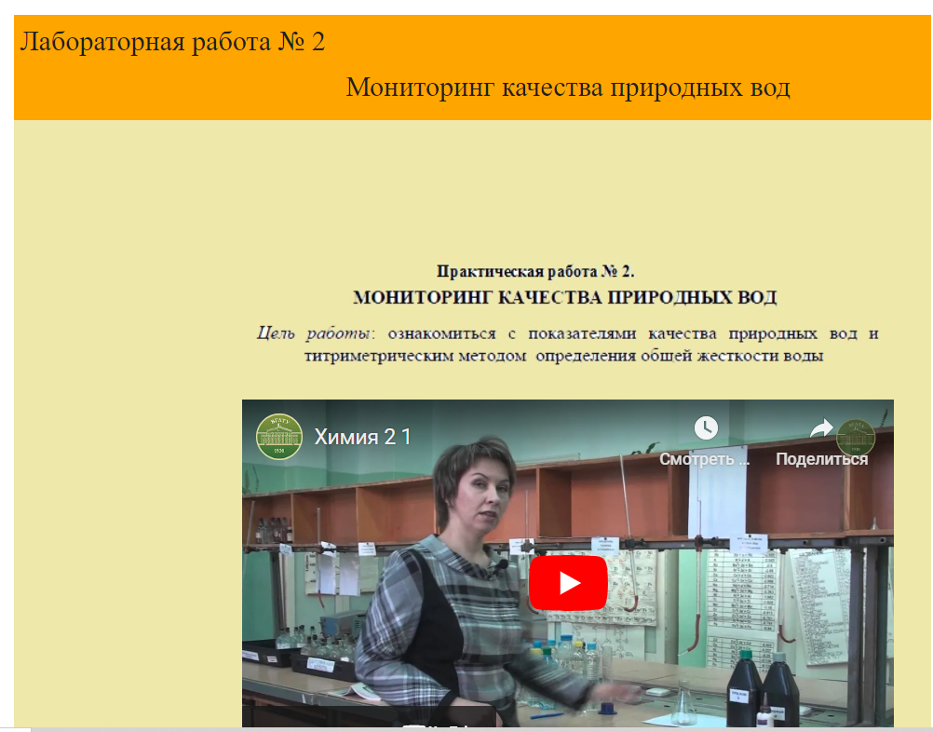
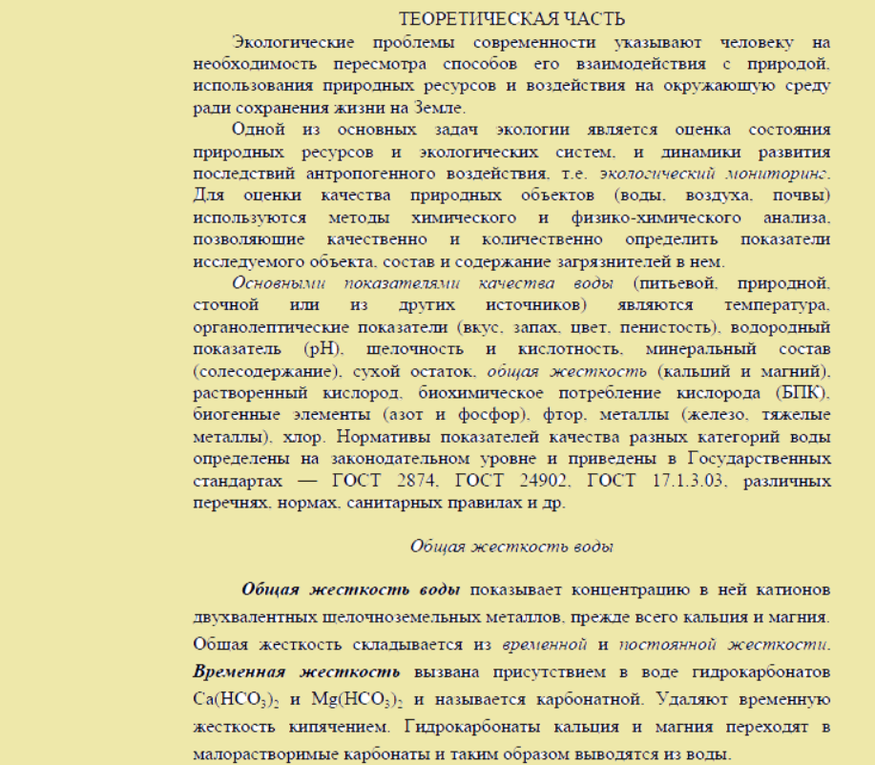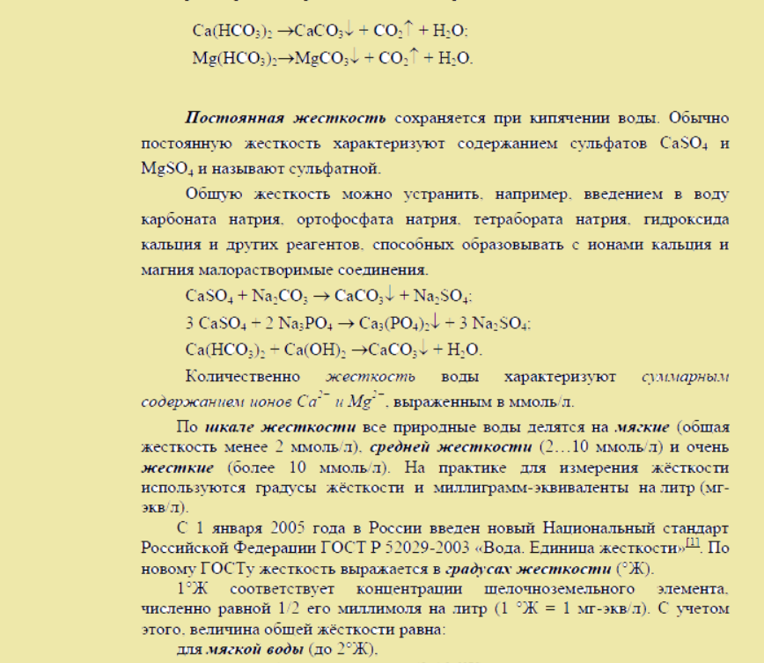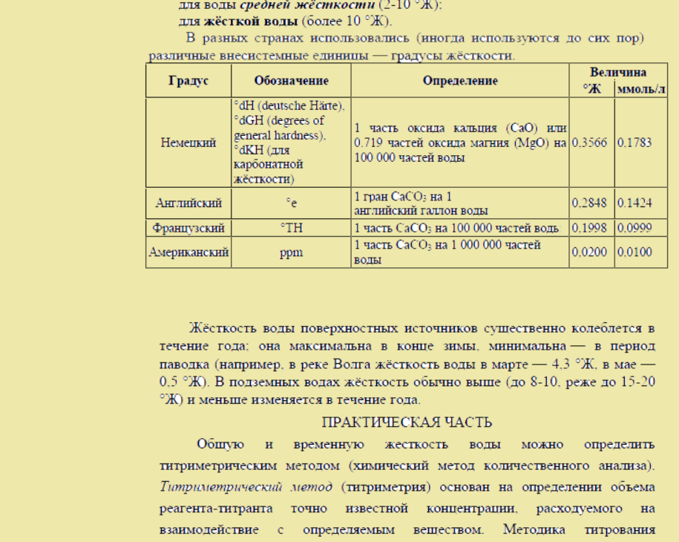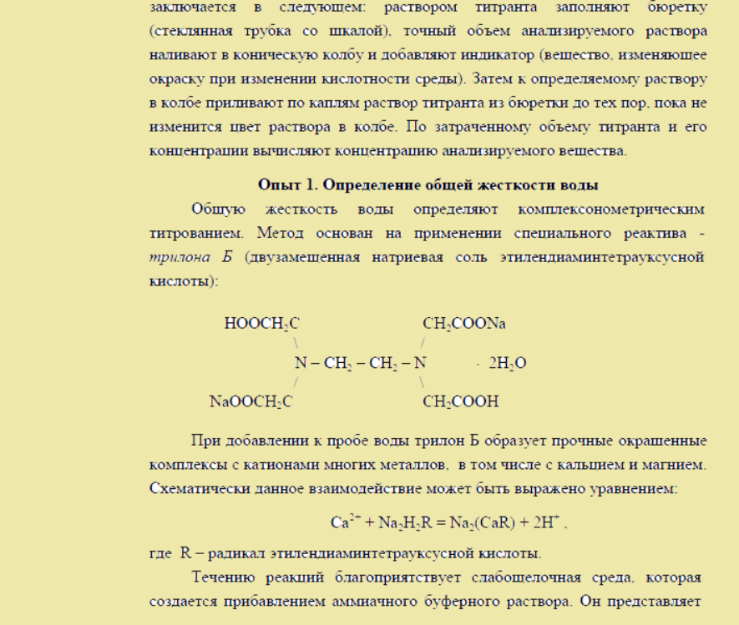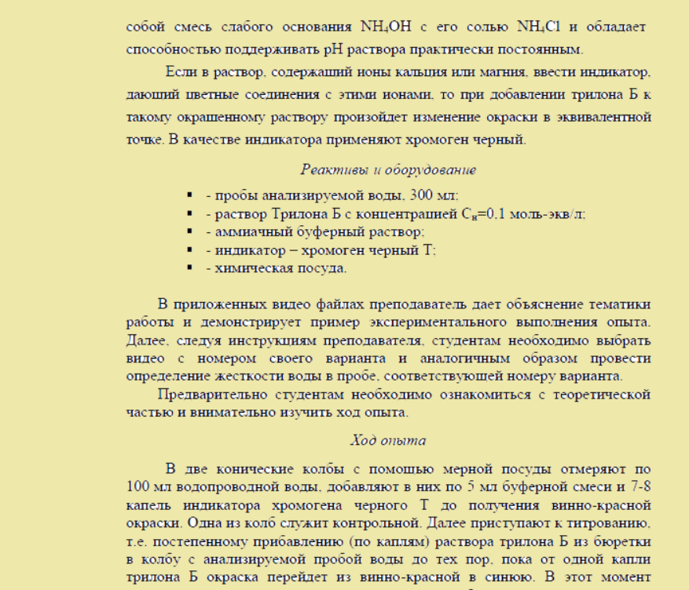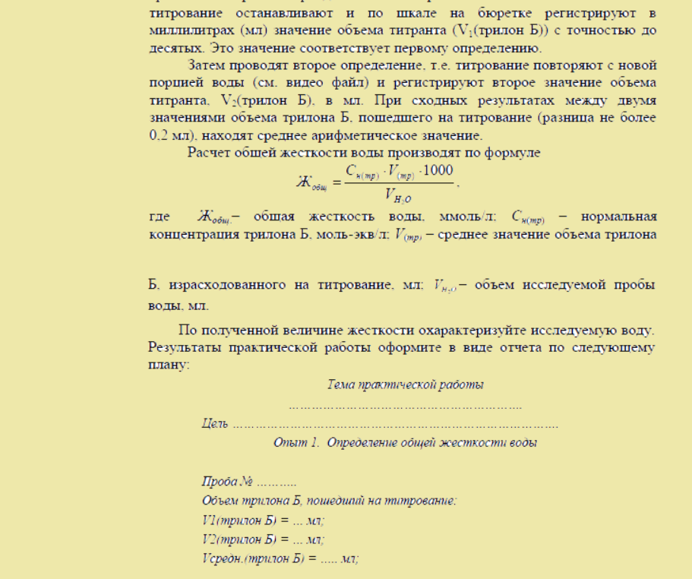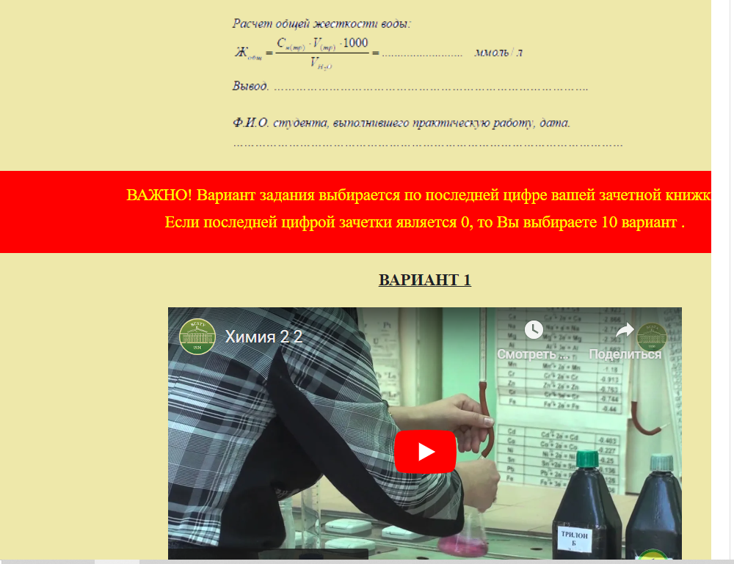
ВАРИАНТ 1
https://www.youtube.com/watch?si=P50B-WkHCZ_p1KDT&embeds_referring_euri=https%3A%2F%2Fcdovgltu.ru%2F&source_ve_path=MzY4NDIsMjg2NjQsMTY0NTA2&feature=emb_share&v=5MGbZSROtjE
ВАРИАНТ 2
https://www.youtube.com/watch?si=b1Wzw8HqyADIPGM0&embeds_referring_euri=https%3A%2F%2Fcdovgltu.ru%2F&source_ve_path=Mjg2NjQsMTY0NTA2&feature=emb_share&v=-UtlkPcUUUI
ВАРИАНТ 3
https://www.youtube.com/watch?si=t6PuCunbsHC5jJEC&embeds_referring_euri=https%3A%2F%2Fcdovgltu.ru%2F&source_ve_path=Mjg2NjQsMTY0NTA2&feature=emb_share&v=bWjm89xpm3c
ВАРИАНТ 4
https://www.youtube.com/watch?si=v6RD-wMYWMxsVHDF&embeds_referring_euri=https%3A%2F%2Fcdovgltu.ru%2F&source_ve_path=Mjg2NjQsMTY0NTA2&feature=emb_share&v=F95TU0Hs3TM
ВАРИАНТ 5
https://www.youtube.com/watch?si=S_-emORCgvtHu30L&embeds_referring_euri=https%3A%2F%2Fcdovgltu.ru%2F&source_ve_path=MzY4NDIsMjg2NjQsMTY0NTA2&feature=emb_share&v=k9SEGnaOoVg
ВАРИАНТ 6
https://www.youtube.com/watch?si=Pycxi8LHUeRoW8Vt&embeds_referring_euri=https%3A%2F%2Fcdovgltu.ru%2F&source_ve_path=MzY4NDIsMjg2NjQsMTY0NTA2&feature=emb_share&v=caFoZubRoqE
ВАРИАНТ 7
https://www.youtube.com/watch?si=jeJf-BnRbg6dp_As&embeds_referring_euri=https%3A%2F%2Fcdovgltu.ru%2F&source_ve_path=MzY4NDIsMjg2NjQsMTY0NTA2&feature=emb_share&v=wav69zrKyt4
ВАРИАНТ 8
https://www.youtube.com/watch?si=3Avv2zZkqG0PBGQl&embeds_referring_euri=https%3A%2F%2Fcdovgltu.ru%2F&source_ve_path=MTY0NTA2LDE2NDUwNg&feature=emb_share&v=kUCnkSr-mzA
ВАРИАНТ 9
https://www.youtube.com/watch?si=PKI_svJh5oAZFG3b&embeds_referring_euri=https%3A%2F%2Fcdovgltu.ru%2F&source_ve_path=MzY4NDIsMjg2NjQsMTY0NTA2&feature=emb_share&v=ed78B2OAgfk
ВАРИАНТ 10

https://www.youtube.com/watch?si=CZ14ZK3tkt9VzVAd&embeds_referring_euri=https%3A%2F%2Fcdovgltu.ru%2F&source_ve_path=MzY4NDIsMjg2NjQsMTY0NTA2&feature=emb_share&v=_1nhWBSUbvY
